Interactive Lunch Pack Designer

# Goal

The goals of todays project are both a product and some more “blurry” skills.

## Product

You are expected to produce the frontend of a website for designing, and ultimately order, pre produced lunch packs.

The user should be given choices to choose different food items, and add them to their lunch pack. These items could be different sandwiches, vegie-snacks (like carrots, cucumbers, nuts etc.), biscuits and what ever you might imagine would be demanded by customers. See the user stories too.

There should also be some standard packs that users can chose, and perhaps modify.

Once modified, or designed from scratch, the price of the lunch pack should be calculated on basis of the price of each food item.

If you have the time, you should be the user the opportunity to design their of favourite sandwich as well.

## International Collaboration Skills

We expect you to collaborate in team of five. Each team have three students from GLR and two students from RTS.

You are supposed to produce a solution together, with the use of your common skills. You will need to communicate in the team in a language that is probably not your native language, in English. Also you will have to negotiate your different habits of how to solve this kind of assignments.

You should also gain some knowledge of the techniques and tools your fellow students are using.

# Background

Several businesses in Denmark, are providing products of this kind, but they a met by different challenges. The biggest challenges are about distribution of the lunch packs. Simply to fresh products in the right place at the right time is hard. Adding custom designed food packs does not make this any easier ☺.

The other challenge is to provide an easy and understandable way to chose and order costumers favourite lunch packs.

We will not go into the distribution issues, but only ask you to give your suggestions of how to present the choices online.

# User stories

* Busy professional adult.
* Ambitious parents
* …

# Building parts

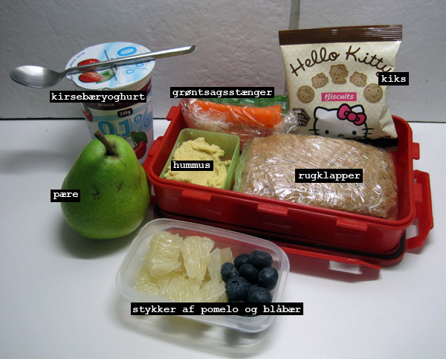

Source code

<https://github.com/Rts-wix/DragAndDropSandwich/tree/master/Drag-N-Drop_sample>

Reference

<https://developer.mozilla.org/en-US/docs/Web>

<http://www.w3schools.com/jsref/default.asp>

Businesses

<http://www.guldbageren-augustenborg.dk/madpakke-bestilling-hoerup.html>

<http://www.123skolemad.dk/>

<http://www.beslist.nl/products/huis_tuin/r/LunchBox/>

Images

<https://www.google.dk/search?safe=off&es_sm=119&tbm=isch&sa=1&q=lunch+pack&oq=lunch+pack&gs_l=img.3...0.0.0.14529235.0.0.0.0.0.0.0.0..0.0....0...1c..27.img..0.0.0.4bTag_rhajk&bav=on.2,or.r_cp.r_qf.&bvm=bv.53760139%2Cd.d2k%2Cpv.xjs.s.en_US.63KCSWWF6Aw.O&biw=1131&bih=702&dpr=1&ech=1&psi=sONUUqOHFYem0wXn24GgBA.1381295033233.1&emsg=NCSR&noj=1&ei=sONUUqOHFYem0wXn24GgBA>